**Experiment 13**

**Q1:**

**XML:**<?xml version="1.0" encoding="utf-8"?>

<LinearLayout xmlns:android="http://schemas.android.com/apk/res/android"

xmlns:app="http://schemas.android.com/apk/res-auto"

xmlns:tools="http://schemas.android.com/tools"

android:layout_width="match_parent"

android:layout_height="match_parent"

tools:context=".MainActivity"

android:orientation="vertical"

>

<TextView

android:layout_width="wrap_content"

android:layout_height="wrap_content"

android:text="Circular Progress Bar"

app:layout_constraintBottom_toBottomOf="parent"

app:layout_constraintEnd_toEndOf="parent"

app:layout_constraintStart_toStartOf="parent"

app:layout_constraintTop_toTopOf="parent"

android:layout_marginTop="60dp"

android:layout_marginLeft="130dp"

android:textSize="40px"

/>

<ProgressBar

android:id="@+id/circularProgressBar"

style="?android:attr/progressBarStyle"

android:layout_width="wrap_content"

android:layout_height="39dp"

android:layout_marginTop="60dp"

android:layout_marginLeft="180dp"

android:layout_centerInParent="true"

android:indeterminate="true" />

</LinearLayout>

**JAVA:**

package com.example.experiment13;

import androidx.appcompat.app.AppCompatActivity;

import android.os.Bundle;

import android.widget.ProgressBar;

import android.view.View;

public class MainActivity extends AppCompatActivity {

private ProgressBar circularProgressBar;

@Override

protected void onCreate(Bundle savedInstanceState) {

super.onCreate(savedInstanceState);

setContentView(R.layout.activity_main);

circularProgressBar = findViewById(R.id.circularProgressBar);

showProgressBar();

performLongRunningTask();

}

private void showProgressBar() {

circularProgressBar.setVisibility(View.VISIBLE);

}

private void performLongRunningTask() {

try {

Thread.sleep(1000);

} catch (InterruptedException e) {

e.printStackTrace();

}

}

}

**Output:**

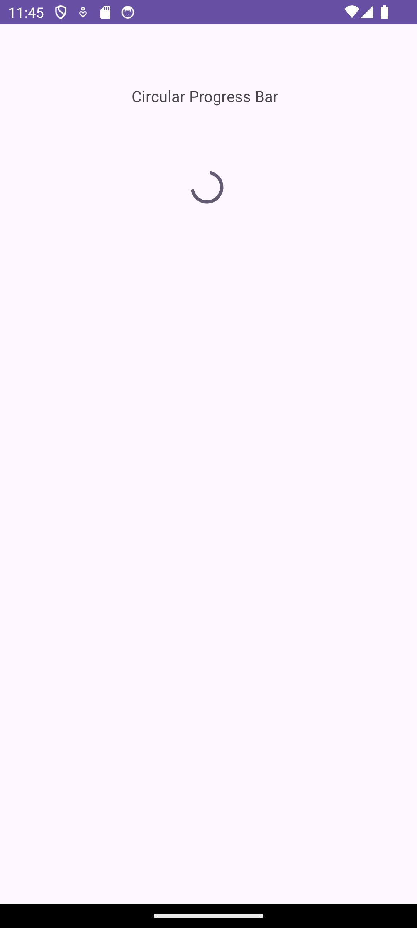

**Q2:**

**XML:**

<?xml version="1.0" encoding="utf-8"?>

<LinearLayout xmlns:android="http://schemas.android.com/apk/res/android"

android:layout_width="match_parent"

android:layout_height="match_parent"

android:orientation="vertical"

android:gravity="center">

<Button

android:id="@+id/downloadButton"

android:layout_width="wrap_content"

android:layout_height="wrap_content"

android:text="Download" />

</LinearLayout>

**XML (Dialog):**

<?xml version="1.0" encoding="utf-8"?>

<LinearLayout xmlns:android="http://schemas.android.com/apk/res/android"

android:layout_width="wrap_content"

android:layout_height="wrap_content"

android:orientation="vertical"

android:padding="16dp">

<ProgressBar

android:id="@+id/progressBar"

style="@style/Widget.AppCompat.ProgressBar.Horizontal"

android:layout_width="200dp"

android:layout_height="wrap_content" />

<TextView

android:id="@+id/textView"

android:layout_width="wrap_content"

android:layout_height="wrap_content"

android:layout_marginTop="8dp"

android:text="Downloading... 0%"

android:textAppearance="?android:attr/textAppearanceMedium" />

</LinearLayout>

**JAVA:**

package com.example.experiment13_;

import android.app.AlertDialog;

import android.os.Bundle;

import android.os.Handler;

import android.view.View;

import android.widget.Button;

import android.widget.ProgressBar;

import android.widget.TextView;

import androidx.appcompat.app.AppCompatActivity;

public class MainActivity extends AppCompatActivity {

private Button downloadButton;

private AlertDialog progressDialog;

@Override

protected void onCreate(Bundle savedInstanceState) {

super.onCreate(savedInstanceState);

setContentView(R.layout.activity_main);

downloadButton = findViewById(R.id.downloadButton);

downloadButton.setOnClickListener(new View.OnClickListener() {

@Override

public void onClick(View v) {

showProgressDialog();

}

});

}

private void showProgressDialog() {

AlertDialog.Builder builder = new AlertDialog.Builder(MainActivity.this);

View dialogView = getLayoutInflater().inflate(R.layout.progress_dialog, null);

builder.setView(dialogView);

builder.setCancelable(false);

progressDialog = builder.create();

progressDialog.show();

final ProgressBar progressBar = dialogView.findViewById(R.id.progressBar);

final TextView textView = dialogView.findViewById(R.id.textView);

final Thread thread = new Thread(new Runnable() {

@Override

public void run() {

for (int i = 0; i <= 100; i++) {

try {

Thread.sleep(100);

} catch (InterruptedException e) {

e.printStackTrace();

}

final int progress = i;

runOnUiThread(new Runnable() {

@Override

public void run() {

progressBar.setProgress(progress);

textView.setText("Downloading " + progress + "% / 100%");

}

});

}

runOnUiThread(new Runnable() {

@Override

public void run() {

progressDialog.dismiss();

}

});

}

});

thread.start();

}

}

**Output:**



S